**To Supply Leftover Food to Poor**

**College name** : KPR college of Arts science and research

**College code** : 19

**Team ID** :

**Team members**

Team Leader Name: Keerthivasan SG

Email: 23bit028@kprcas.ac.in

Team member1: Kamaleswaran J

Email: 23bit018@kprcas.ac.in

Team member2: Kavin V

Email: 23bit021@kprcas.ac.in

Team member3: Karuppusamy D

Email: 23bit020@kprcas.ac.in

**FoodConnect Salesforce Project Guide**

**Introduction**

FoodConnect is a custom Salesforce application built to streamline the process of food distribution and volunteer management. The solution demonstrates the use of Salesforce fundamentals such as custom objects, object relationships, automation through flows, Apex triggers, reporting, dashboards, and sharing rules. The platform provides NGOs and organizations with tools to monitor food collection sites, distribution venues, assigned volunteers, ongoing tasks, and execution outcomes while ensuring efficient reporting and accessibility.

**1. Setting Up a Developer Account**

Before starting development, a Salesforce Developer Org is required:

* Sign up at [Salesforce Developer Signup](https://developer.salesforce.com/signup).
* Enter details such as Name, Email, Role = Developer, Company/College, Country = India, and a unique Username in email format.
* Confirm the registration via email, then set a password and security question.
* This developer environment will serve as the workspace to design and test the FoodConnect application.

**2. Designing Custom Objects**

In Salesforce, objects function like database tables. FoodConnect uses the following objects:

**Drop-Off Point**

* **Use Case**: Represents locations where food items are collected.
* **Key Field**: Drop-Off Point Name.
* **Enabled Features**: Reporting, Field History, Activities, Global Search.

**Venue**

* **Use Case**: Identifies main centers where collected food is distributed.
* **Key Field**: Venue Name.
* **Enabled Features**: Reporting, Field History, Activities, Global Search.

**Volunteer**

* **Use Case**: Stores information about individuals offering assistance.
* **Key Field**: Volunteer Name.
* **Enabled Features**: Reporting, Field History, Activities, Global Search.
* 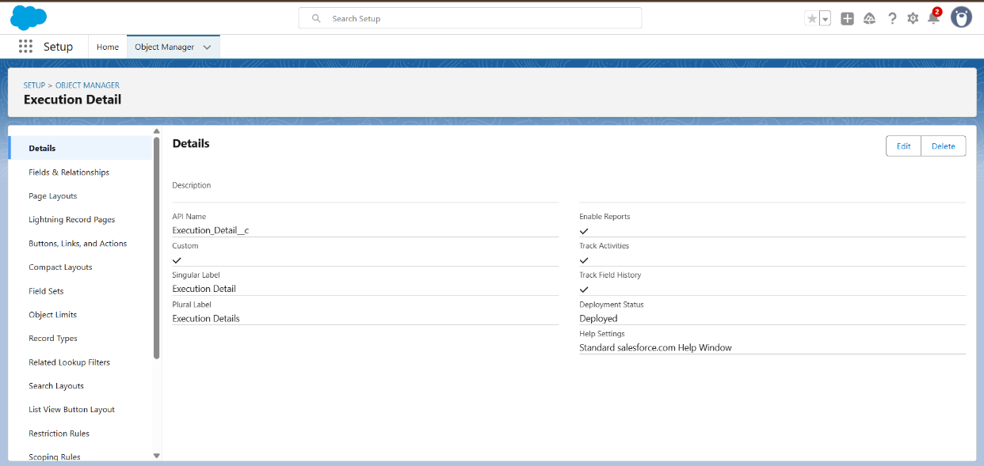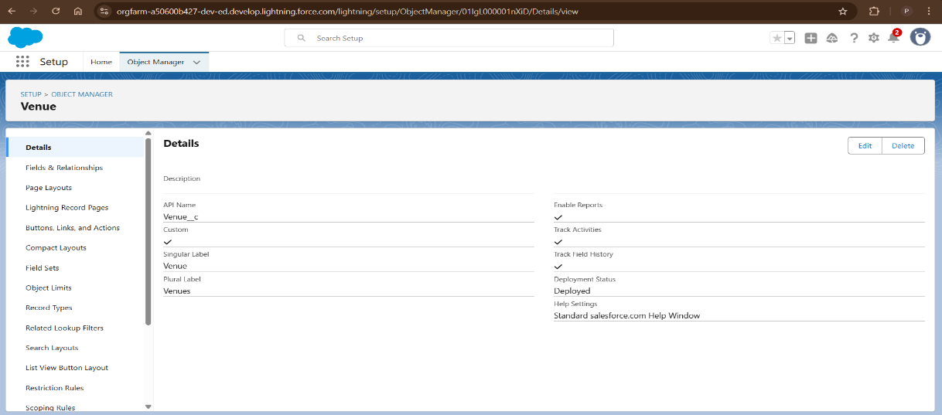
* 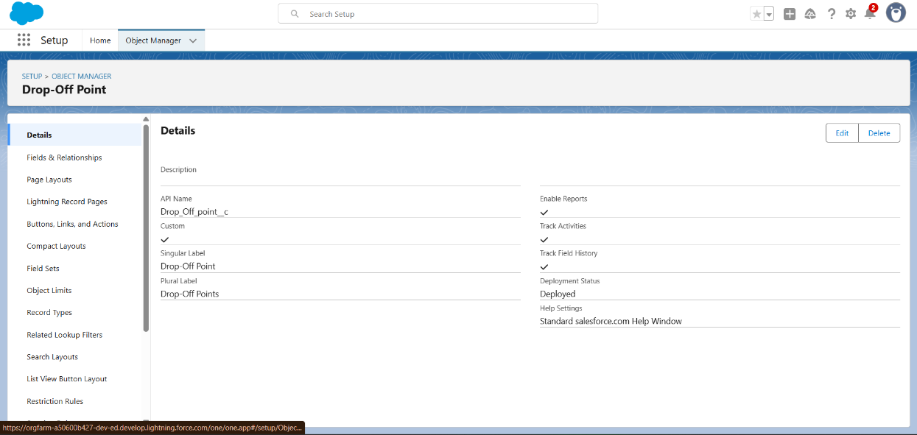
* 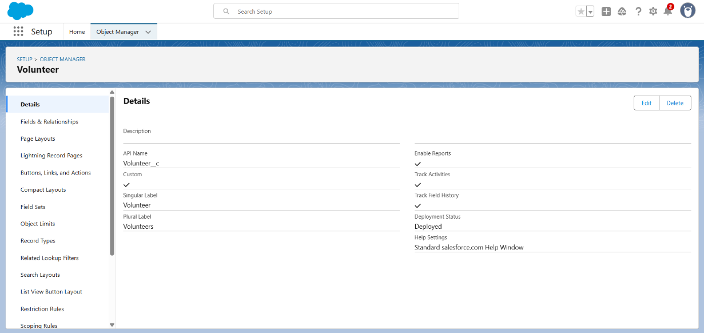**Use Case**: Represents food distribution operations or activities.
* **Key Field**: Task Name.
* **Enabled Features**: Reporting, Field History, Activities, Global Search.

**Execution Detail**

* **Use Case**: Tracks how tasks are carried out, including volunteer involvement.
* **Key Field**: Execution Detail Name.
* **Enabled Features**: Reporting, Field History, Activities, Global Search.

**3. Creating Tabs**

Custom tabs give users direct access to objects from the app menu.

* Tabs created for: Venue, Drop-Off Point, Task, Volunteer, Execution Detail.
* Path: Setup → Tabs → New Tab → Select Object → Assign Style. 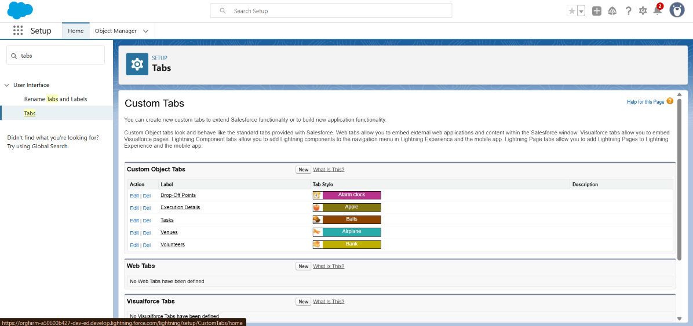

**4. Building the Lightning App: FoodConnect**

The Lightning App ties everything together:

1. Navigate to App Manager → New Lightning App.
2. Enter details: **App Name** = FoodConnect.
3. Choose **Standard Navigation** style.
4. Add navigation items: Home, Venue, Drop-Off Point, Task, Volunteer, Execution Detail, Reports.
5. Assign the app to the System Administrator profile.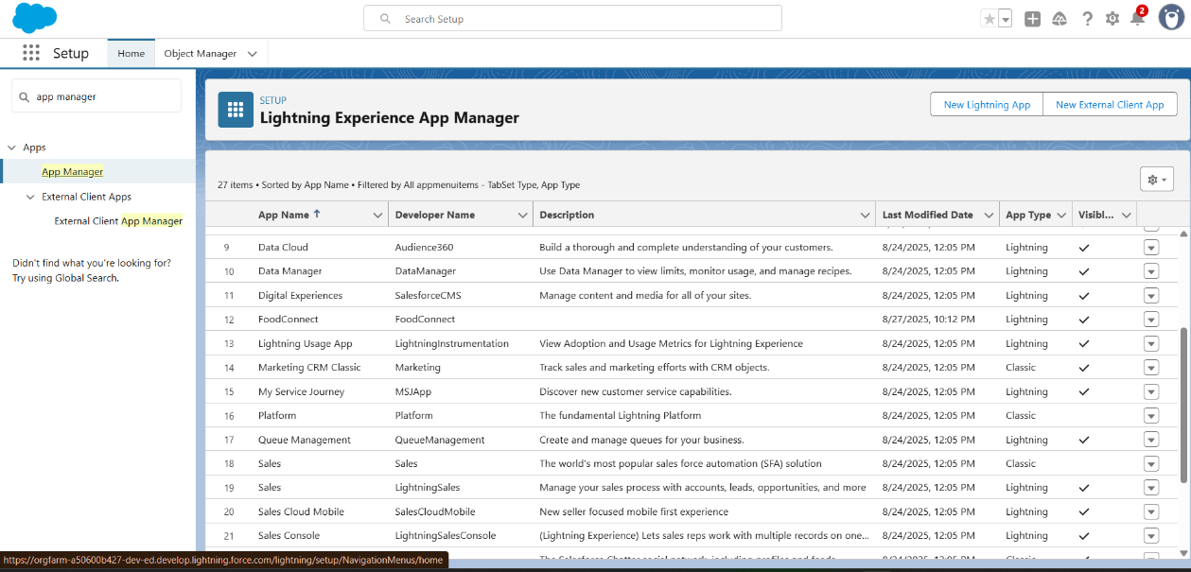

**5. Defining Relationships**

Object relationships define how records interact:

* Volunteer → Drop-Off Point: **Master-Detail**
* Execution Detail → Volunteer: **Master-Detail**
* Execution Detail → Task: **Master-Detail**
* Drop-Off Point → Venue: **Lookup**
* Task → Venue: **Lookup**
* Task → Drop-Off Point: **Lookup**

These links allow cross-object reporting and dashboards.

**6. Adding Fields**

To capture more data, the following custom fields were added:

* **Venue**: Contact Email, Contact Phone, Geolocation, Venue Description.
* **Drop-Off Point**: Secondary Location (Geolocation), Distance Formula, State (Picklist).
* **Task**: Task ID (Auto Number), Date, Food Category (Multi-Picklist), People Served, Feedback, Rating.
* **Volunteer**: Volunteer ID (Auto Number), Gender, Date of Availability, Age, Email, Address, Date of Birth.
* **Execution Detail**: Execution ID (Auto Number).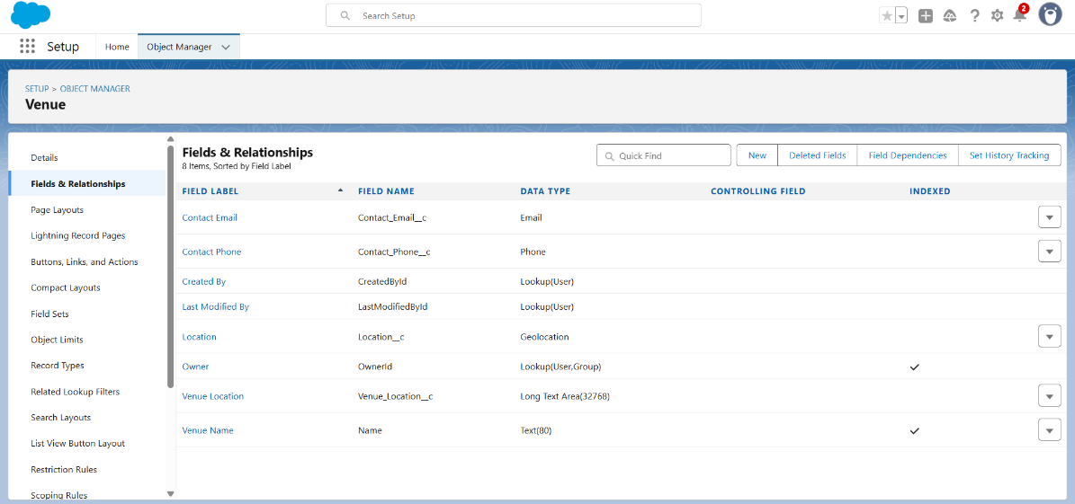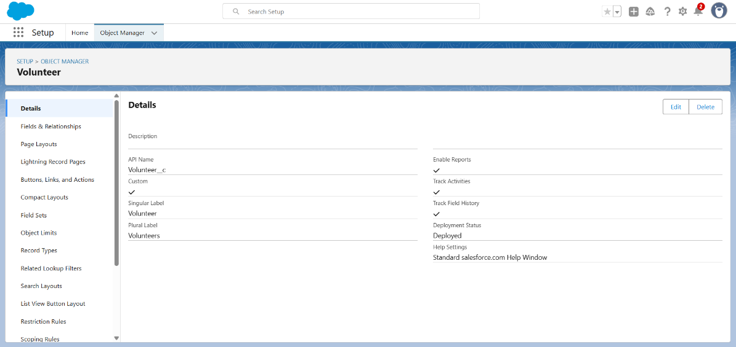

**7. Automation with Flows**

A **Screen Flow** was created to simplify Venue creation:

* Captures Venue Name, Contact Information, Description, Latitude, and Longitude.
* Saves the data directly into a new Venue record.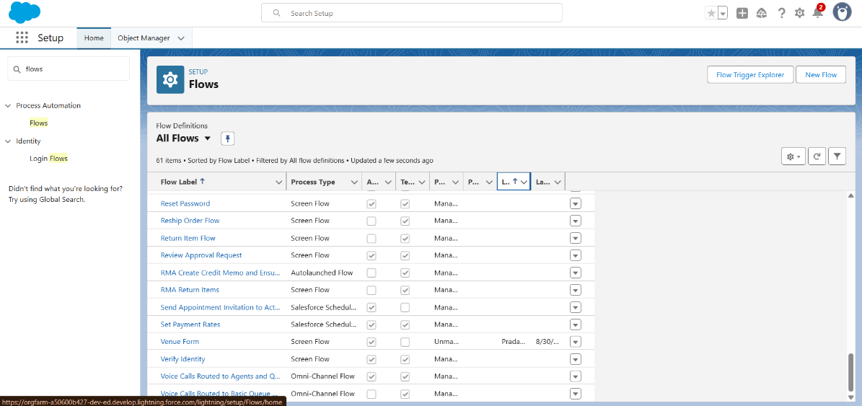

**8. Apex Trigger**

A small trigger was written to automatically assign distance values:

trigger DropOffTrigger on Drop_Off_point__c (before insert) {

for (Drop_Off_point__c d : Trigger.new) {

d.Distance__c = d.Distance_Calculation__c;

}

}

This ensures that the “Distance” field always reflects the calculated formula.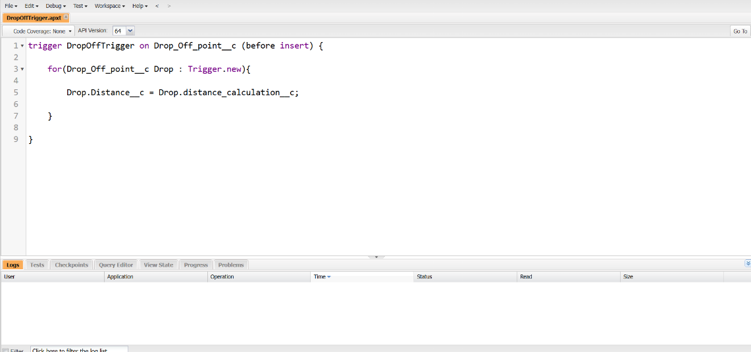

**9. Profiles, Users & Public Groups**

* **Custom Profile**: NGO Profile (cloned from Standard Platform User).
* **Users**: Three NGO users created (Iksha Foundation, NSS, Street Cause).
* **Public Groups**: One for each NGO with the relevant users included.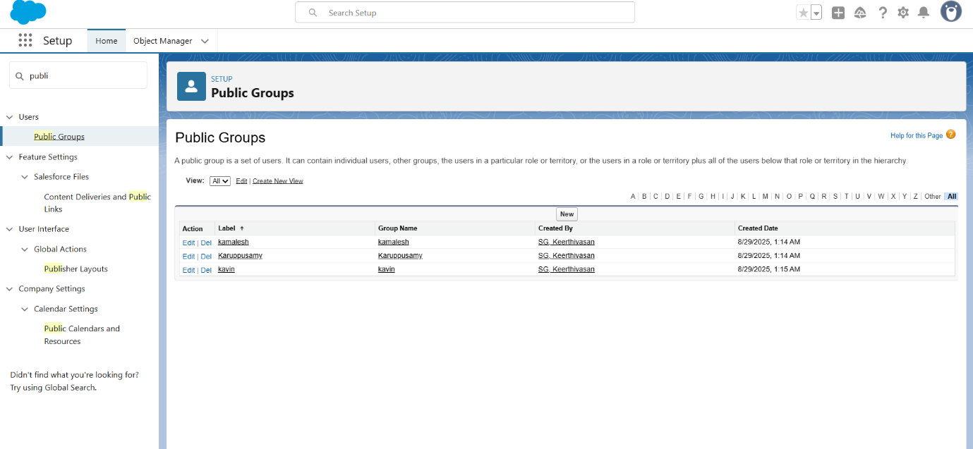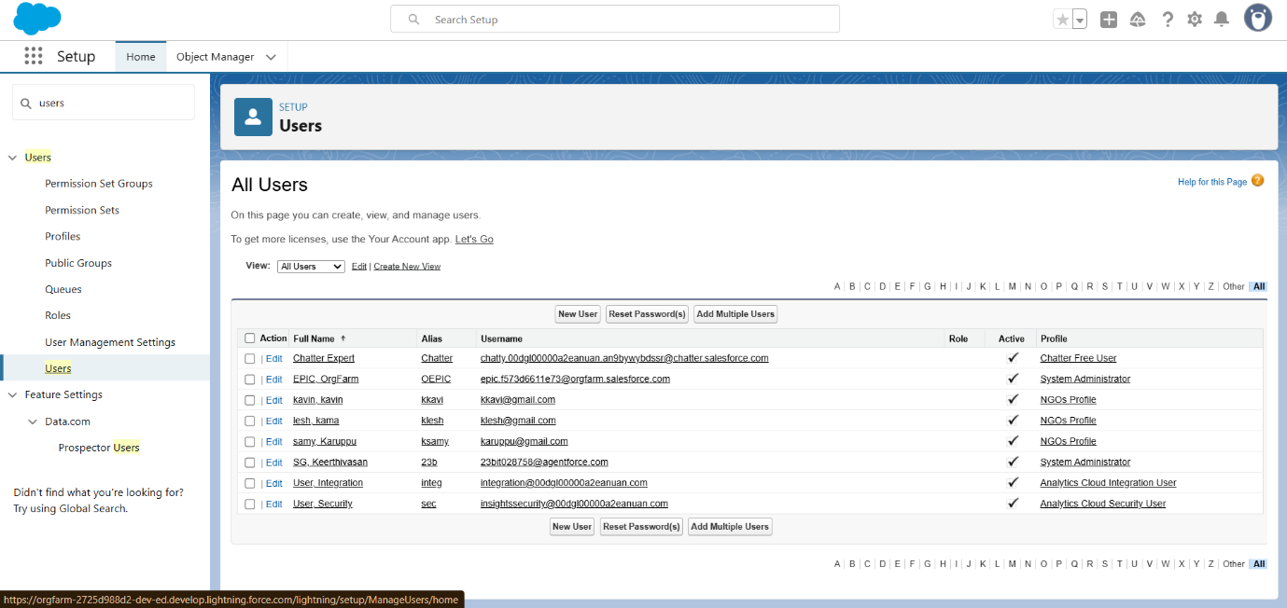

**10. Reports & Dashboards**

**Report Types**

1. **Venues with Drop-Off Points and Volunteers**
2. **Volunteers with Execution Details and Tasks**

**Reports**

* Venue & Drop-Off Report: Shows venue names, drop-off locations, and distances.
* Volunteer Task Report: Displays volunteers along with related tasks and execution records.

**Dashboard: Organization Details**

* Components:
  + Lightning Table (Venue & Drop-Off Report)
  + Line Chart (Volunteer Task Report)
  + Optional: Custom NGO logo or image.

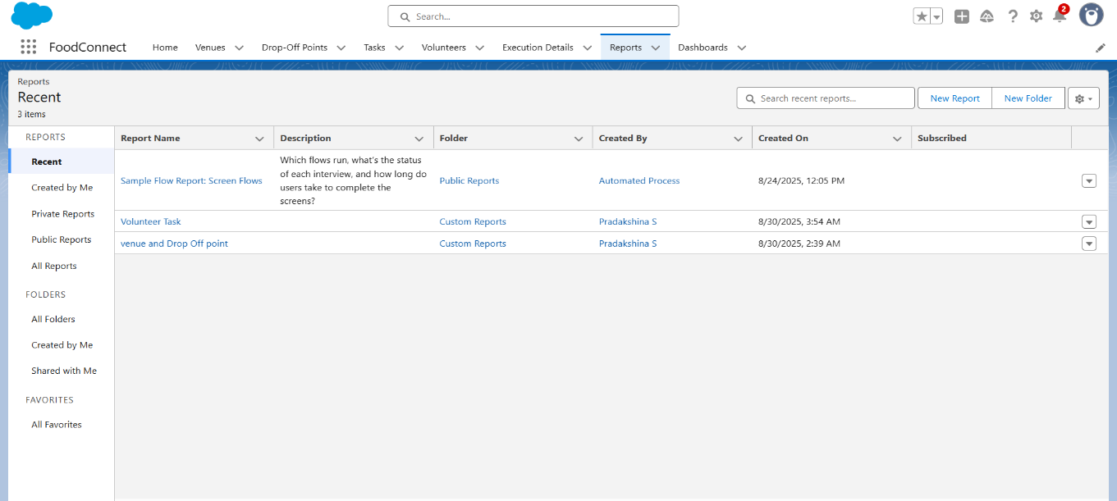

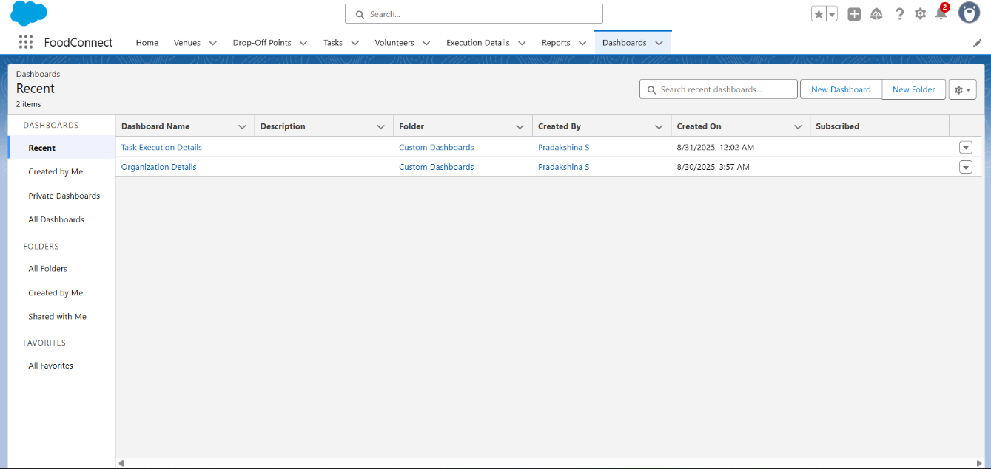

**11. Sharing Rules**

To grant record access based on location:

* Distance < 15 km → Shared with Iksha Group.
* Distance 15–30 km → Shared with NSS Group.
* Distance 30–50 km → Shared with Street Cause Group.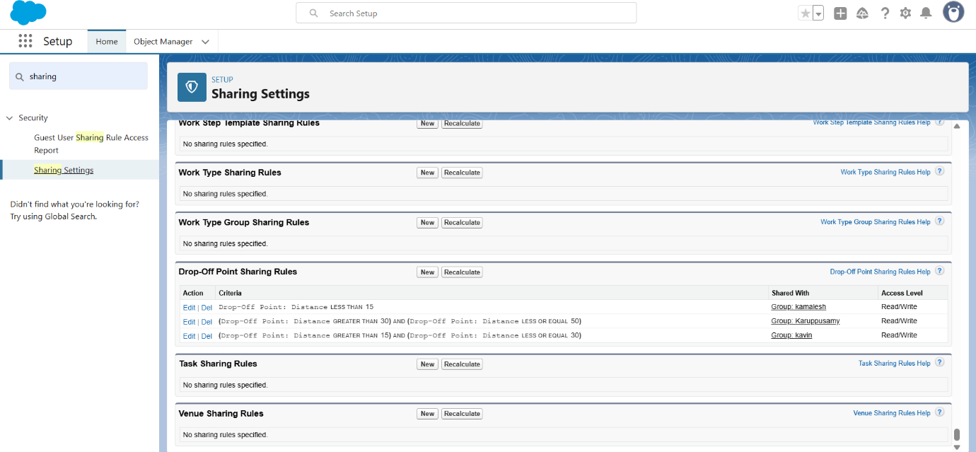

**12. Custom Home Page**

Using Lightning App Builder:

* Added the Venue Flow for quick record entry.
* Added the Dashboard for real-time insights.
* Set this as the default Home Page for FoodConnect.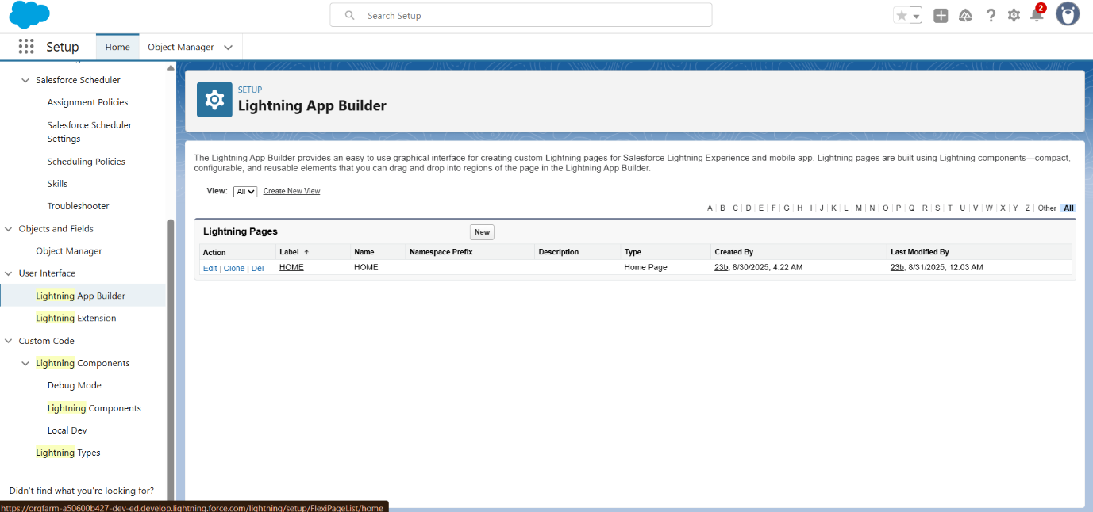

**Final Notes**

The FoodConnect application showcases how Salesforce can be tailored for non-profits:

* Manage collection points, venues, and tasks.
* Capture structured volunteer data.
* Automate repetitive actions with Flows and Triggers.
* Control access through profiles, groups, and sharing rules.
* Provide actionable insights with Reports and Dashboards.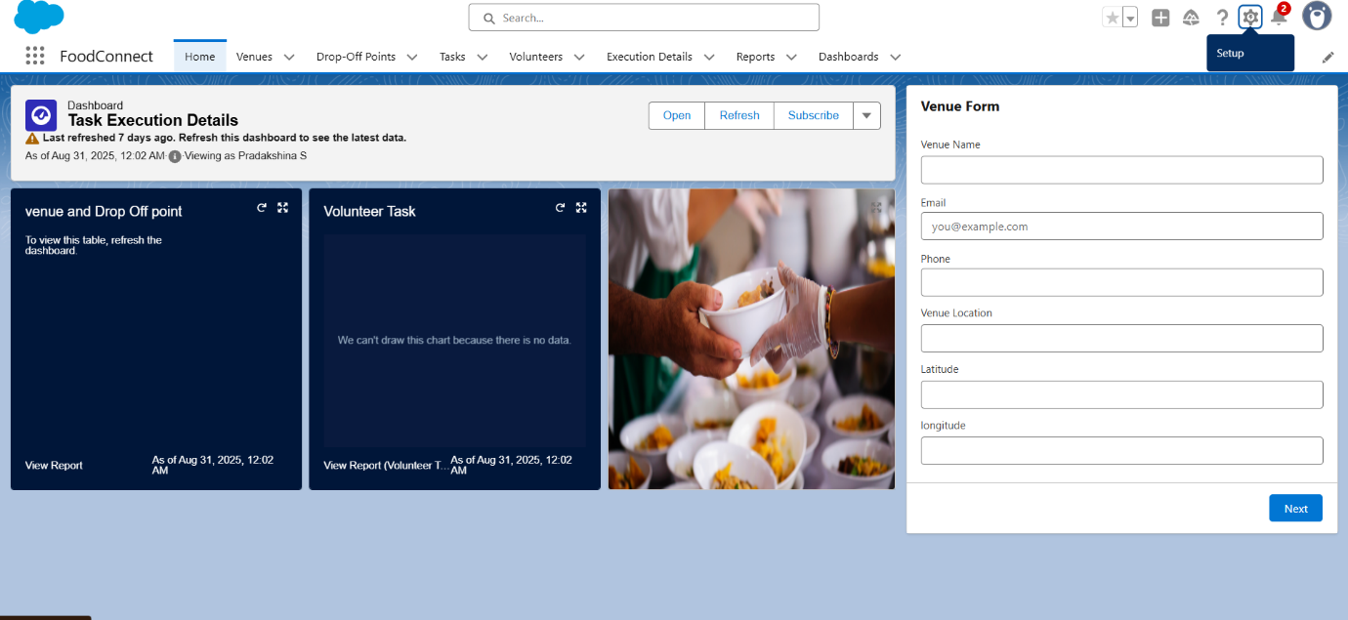

👉 Overall, FoodConnect demonstrates how technology can empower social organizations to improve coordination and maximize community impact.